

**CPT113 ASSIGNMENT I REPORT**

Electronic Covid – 19 Passport Information System

**NAME :** SYED MUHAMMAD HAIKAL BIN SYED HUSNI

**MATRIC NO :** 153086

**DUE DATE :** 19/12/2021

**UML DIAGRAM**

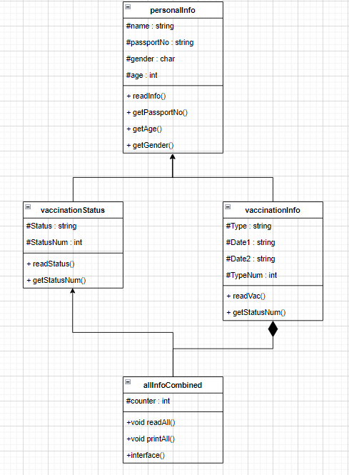

**SPECIFICATION OF REQUIREMENT**

|  |  |
| --- | --- |
| **Input** | Name  Gender  Passport Number  Age  Vaccination Status  Vaccine Type  1st Vaccination Date  2nd Vaccination Date |
| **Output** | List of all individual personal informations  Statistical informations   * Total number of individuals who received certain vaccines * Total number of individuals fully vaccinated,partially or un-vaccinated * Total number of individuals vaccinated according to age * Total number of individuals vaccinated according to gender |
| **Process** | Sorting, arranging, addition, array manipulation |
| **Formula** | Counter = counter +1 |

**TEST CASES ( Sample input & output)**

1. Main menu

2. Other choices does not work because there are no information stored

3. Input how many personal informations

(in the test cases (4) is used) So, 4 total individual informations

(because the program is for passport control officers to retrieve informations not for user to input on their own I assumed)

Also input informations

* name
* gender
* passport number
* age
* vaccination status
* vaccination information (type and dates)

Below test case is for **FULLY VACCINATED.**

Below test case is for **PARTIALLY VACCINATED.**

Below test case is for **NOT YET VACCINATED**

Below test case is also for **PARTIALLY VACCINATED.**

4. Display all current information at the end of the reading.

5. Update vaccination by inserting the passport number of an individual you wish to change

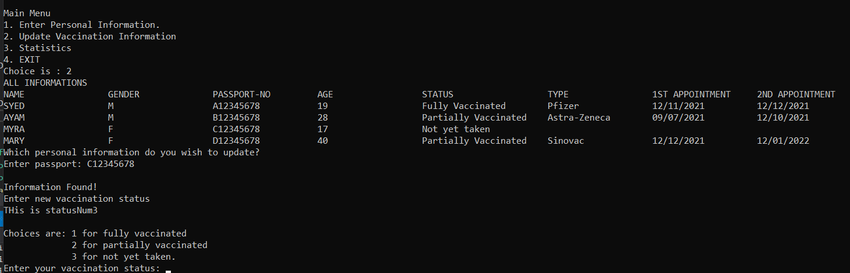

6. Information is updated in the information table.

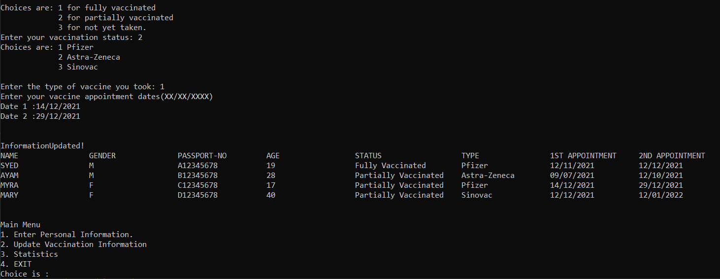

7. Statistics (display statistics based on the last time the information table is updated.)

Display total individual

* **FULLY VACCINATED**
* **PARTIALLY VACCINATED**
* **NOT YET VACCINATED**

Display total individual who took specific vaccine types

* **PFIZER**
* **ASTRA-ZENECA**
* **SINOVAC**

Display total individuals information in the program based on ranged of ages.

* **Age(12-18)**
* **Age(19-39)**
* **Age(40 and above)**

Display total individuals information in the program based on their gender

* **MALE**
* **FEMALE**

**( For references)**

